**Web API 201**

For this 201 course I have designed backend application for an Employee Management API with different end-points (method as GET, POST, PUT and DELETE) using Rest API and .Net MVC.

And implemented unit testing to test all layers () of the application.

**End to end testing using Postman tool**

**Screen capture for GET request using Postman tool:**

**Case 1:** when Request is correct.

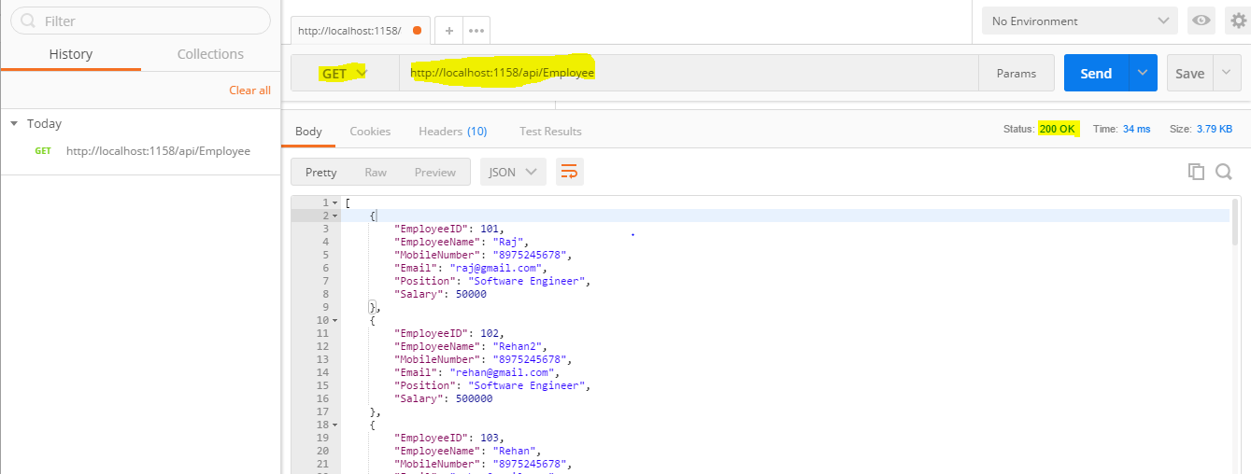

**Case 2:** when Request is incorrect.

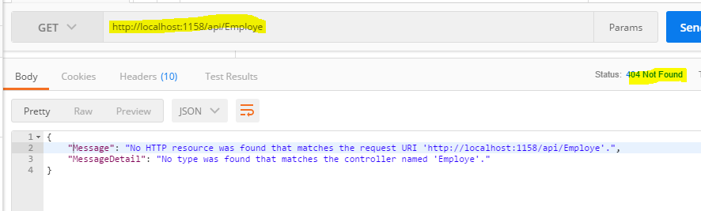

**Screen capture for GET by ID request using Postman tool:**

**Case 1:** when Request id is correct.

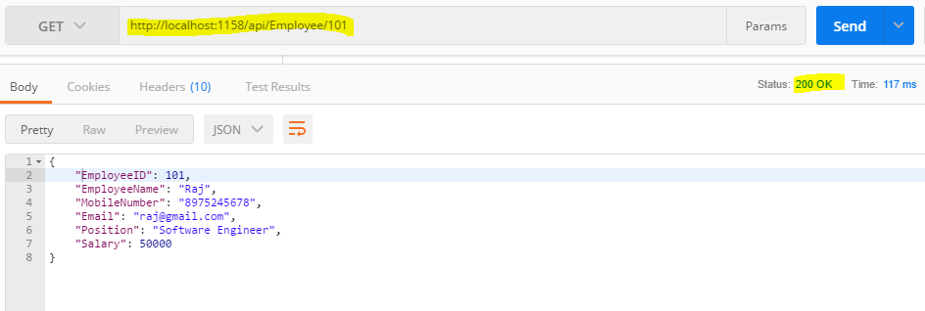

**Case 2:** when Request id is not correct.

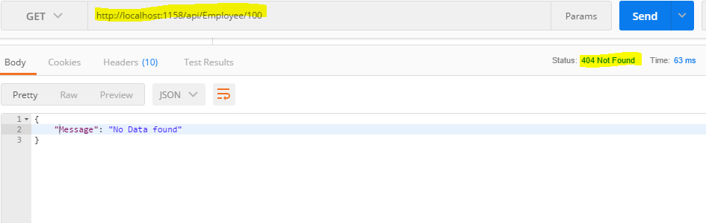

**Screen capture for HTTP POST request using Postman tool:**

**Case 1:** when Request is correct.

1. **Before sending the request:**

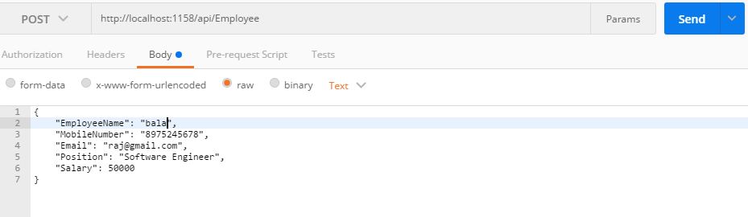

1. **After sending the request:**

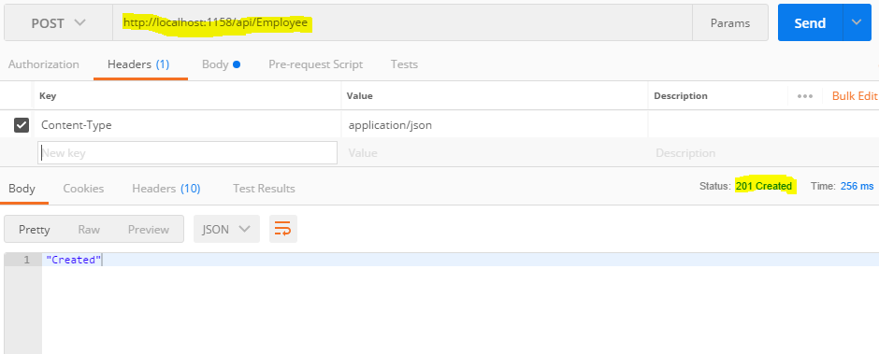

**Case 2:** When request is not in correct format.

500 Internal Server error getting when request is not in correct format. Generally it will accept JSON format but when text format request it will receive then it will send status code 500.

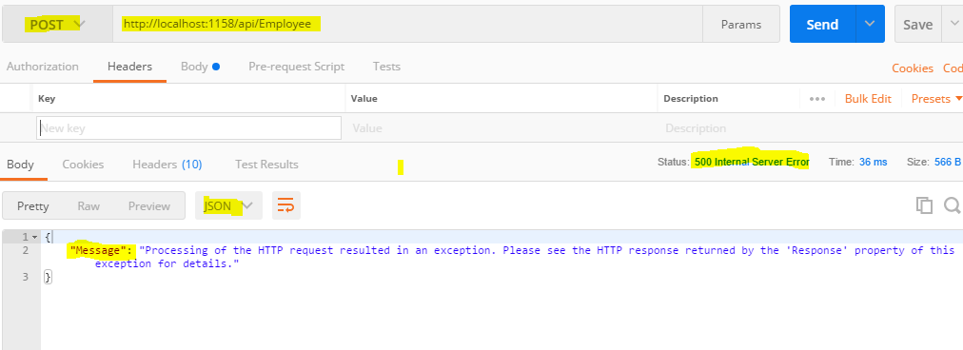

**Case 3:** when Request is not correct.

Here Email is mandatory to include for POST request. So, if Email will not be included then API will send

400 status code for Bad Request.

Below screenshot is for data I am sending to API.

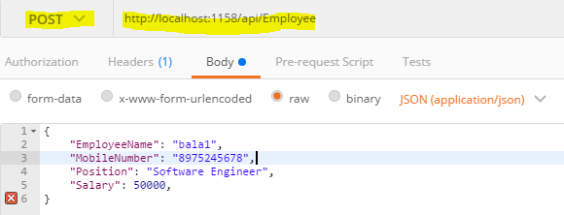

Below screenshot is for result status.

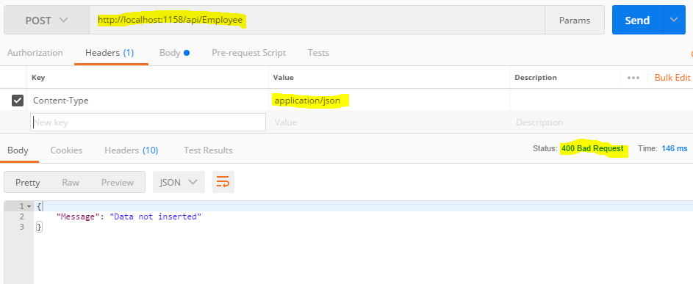

**Screen capture for HTTP DELETE request using Postman tool:**

**Case 1:** when Request is correct.

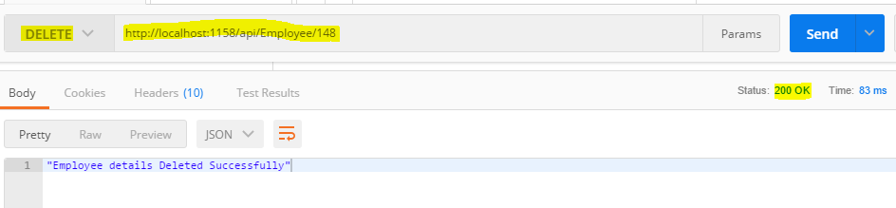

**Case 2:** when Request id is not correct.

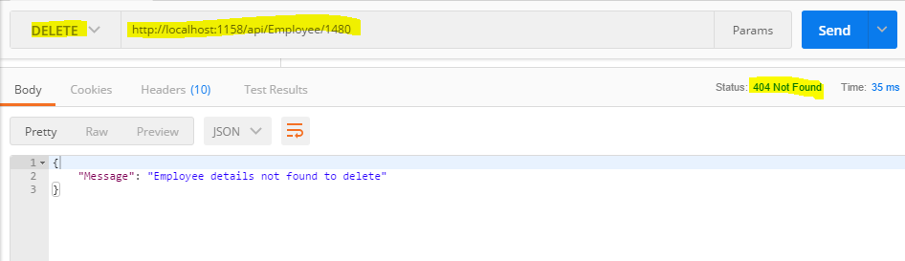

**Screen capture for HTTP PUT request using Postman tool:**

**Case 1:** when Request is correct.

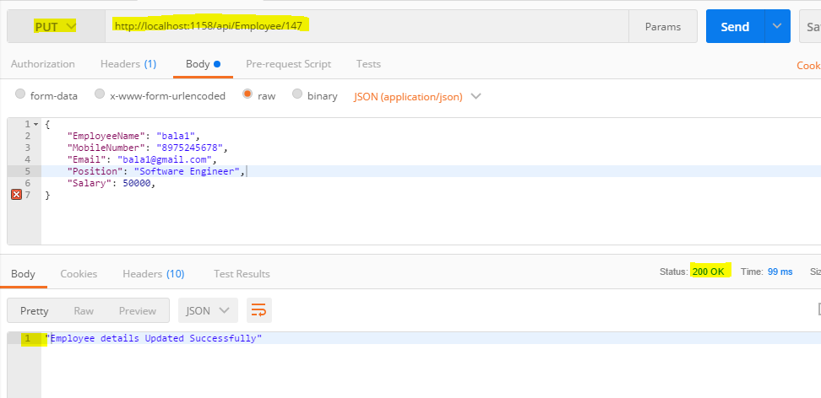

**Case 2:** when Request id is not correct.

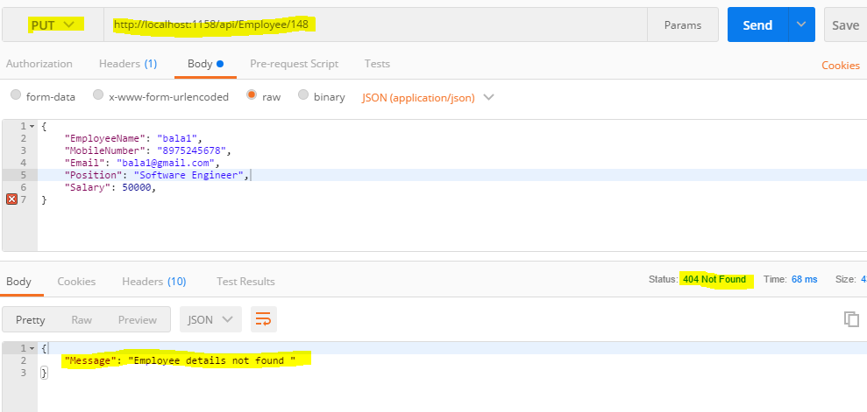

**Case 3**: When Content-Type →application/json; not match.

In this scenario 500 internal server error getting.

